CRUISE OF 8 DAYS / 7 NIGHTS

Croatia and Montenegro

DUBROVNIK - MLJET - KORCULA - SIBENIK - TROGIR - SPLIT - VIS - HVAR - KOTOR - DUBROVNIK

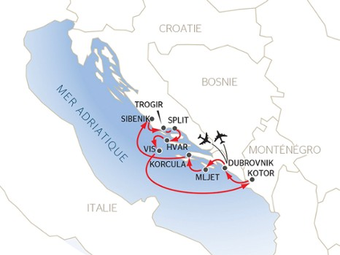
Enjoy a breath-taking journey throughout the beautiful landscapes of Croatia and Montenegro, in which you will discover beautiful cities as well as places where nature is queen. Dive into the striking beauty of the Dalmatian coast, stroll through Dubrovnik "the pearl of the Adriatic", Trogir, Hvar, Korcula or Kotor, as well as the national parks of Mljet and Krka.
CRUISE HIGHLIGHTS
•
EXCURSIONS INCLUDED:
•
•

•
Fantastic variety of architecture
Stunning landscapes and the splendid
Bay of Kotor
Each island is more beautiful than the last
•
Untamed spectacle
waterfalls
of natural
•
Beautiful walled cities along the
Dalmatian Coast

CRUISE PROGRAM (8 DAYS / 7 NIGHTS)
(Optional Pre-tour 3 nights/4 days - Slovenia - separate)

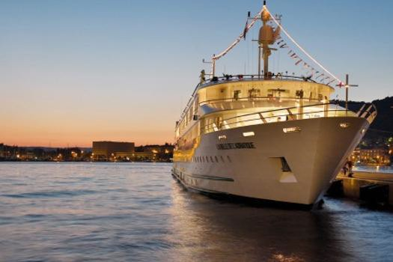
Day 1 July 18 : DUBROVNIK
Arrive at Dubrovnik Airport - Private transfer to cruise port. Passengers are welcome to board our ship at 5:00 p.m. After comfortably settling into your cabins, we'll introduce our crew at a welcome cocktail before dinner. The evening is free to do as you please.

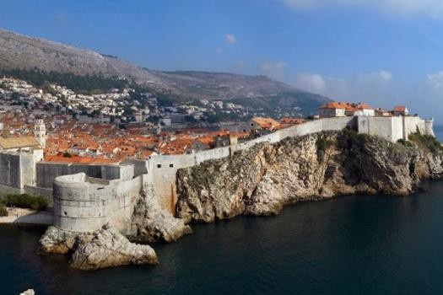
Day 2 July 19 : DUBROVNIK
Join us on an excursion for both packages: Guided tour of Dubrovnik. In the afternoon, feel free to sightsee in the city on your own. We suggest a stroll around the ramparts.

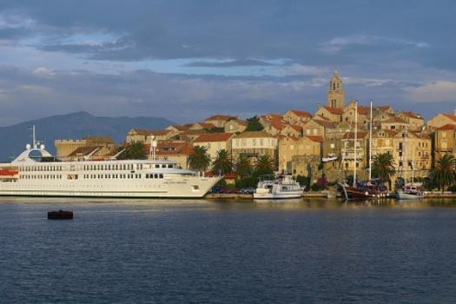
Day 3 July 20 : MLJET - KORCULA
Join us on an excursion for both packages: Excursion to Mljet, one of the most beautiful islands in the Adriatic.
This afternoon, join us for the excursions proposed:
CLASSIC: Guided tour of Korcula.
DISCOVERY: Buggy safari in Korcula. You will enjoy buggy driving on gravel roads through gorgeous landscapes full of olive groves and vineyards. We'll indulge in a tasting of local products at the end of our tour. Tonight's dinner will be followed by traditional sword dancing.

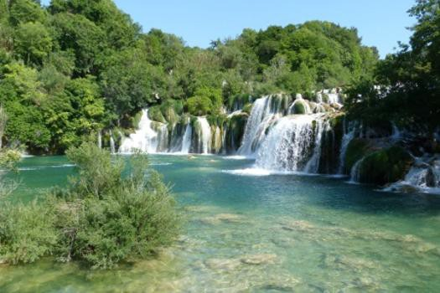
Day 4 July 21 : KORCULA - SIBENIK
Our ship will cruise during the morning. Join us for the excursions proposed:
CLASSIC: Guided tour of Sibenik, the oldest Slavic city on the coast, and the Krka Falls.
DISCOVERY: Hike through the Krka National Park on walkways leading past lakes and waterfalls and down to Skradin.
Enjoy an evening of onboard entertainment.

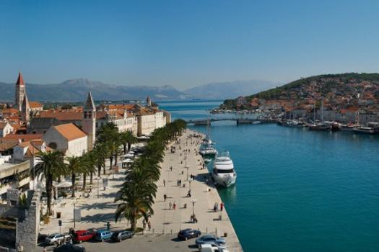
Day 5 July 22 : SIBENIK - TROGIR - SPLIT
Join us on an excursion for both packages: Tour of Trogir. Long considered one of the best spots to visit on the Dalmatian coast, Trogir is a treasure trove of delights.
This afternoon, join us on an excursion for both packages: Guided tour of Split, a young city where life is bursting around Diocletian's Palace.

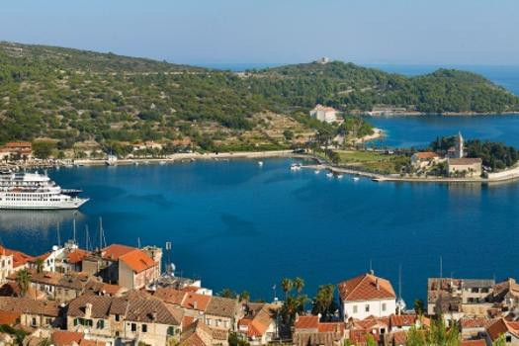
Day 6 July 23 : SPLIT - HVAR - VIS
Join us for the excursions proposed:
CLASSIC: Guided tour of Hvar, nicknamed the Croatian Saint-Tropez.
DISCOVERY: Urban hike on Hvar Island to the fortress, this excursion is the best way to discover the hidden treasures of Hvar Town.
This afternoon, join us for the excursion proposed:
DISCOVERY: At the port of Vis, we'll pick up our bikes and set out with our guide for a bike tour of the island. Tonight's our special gala dinner and evening.

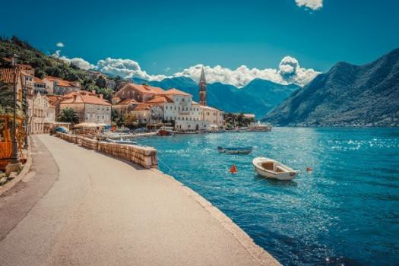
Day 7 July 24 : KOTOR - DUBROVNIK
Our ship will cruise during the morning. Join us on an excursion for both packages: Guided tour of Kotor and exploring the old town on foot.

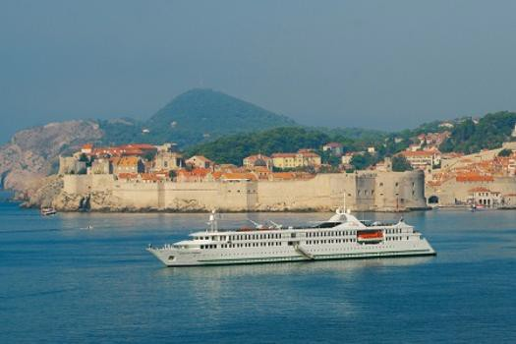
Day 8 July 25 : DUBROVNIK
Enjoy one last buffet breakfast on board before disembarking at 9:00 a.m. Transfer to airport.
End of services.

This cruise offer includes
Your cruise with all meals from dinner the first evening to breakfast on the final day - onboard drinks included (except for drinks from our special lists) - double- occupancy cabin with shower in bathroom - excursions included in the package selected - assistance from our onboard multi-lingual host/hostess - welcome cocktail - gala dinner - onboard entertainment - travel assistance and repatriation insurance - all port fees.
This offer does not include
Drinks from our special lists, or drinks ordered during excursions
- cancellation and baggage insurance - transfers/travel to and from departure/ arrival points - personal expenses.
Transport
Port-to-port cruise, with transfer.
Requirements
Valid passport required. Non-EU nationals are advised to consult their embassy or consulate.
THE CROISIEUROPE DIFFERENCE

- All meals included - DRINKS INCLUDED with meals and at the bar
- Refined French cuisine - Gala dinner and evening - Welcome cocktail
- Free Wi-Fi onboard
- Headsets are included for excursions
- Official welcome from the captain and crew
- Onboard activities
- All port fees included

PRICE:
Croatia & Montenegro Cruise
Price: $5,160 per person based on double occupancy

Croatia & Montenegro Cruise + Slovenia (pre-tour)
Price: $7,069 per person based on double occupancy

Land Portion:
THE ABOVE RATE DOES NOT INCLUDE:
- Air tickets
- Guided tours, entrance fees, coach, train and boat transfers not indicated above
- Lunches and dinner where not specified
- Tips and personal expenses
- Anything not stated in "What's included"

Tips are NOT included. The ship recommends about 10 euros per person/ per day while onboard. Guides generally receive 10-20 euros per day/ per person for a full day and 5-10 euros for a ½ day tour. Drivers 5-10 euros per day/per person.
Restaurants, of course, you can pay what you like, but 10% -15% is appreciated in Croatia and Slovenia.

***Important note! We have 10 upper deck cabins reserved.
First come- first-served.

BOOKING CONDITIONS:

$3,000 NON-REFUNDABLE DEPOSIT PAYMENT
TOTAL DUE MARCH 1, 2024
FINAL BALANCE DUE APRIL 1, 2024

Terms & Conditions:
Must abide by all airline, regional and country rules, and regulations throughout the trip. Note - we must be prepared to follow any rules in place at the time of our visit. Must be fully vaccinated and boosted. Highly recommend the flu vaccine.
Must carry full travel insurance.

Travel Insurance:
You may use any travel insurance company you wish; however, World Exposures will need a copy of the insurance policy. Travel Guard is our preferred insurance company (my husband, Jim works for Travel Guard and we honestly believe they offer the most comprehensive coverage). We recommend that you obtain coverage within 14 days of booking (to make sure any pre-existing conditions are covered).

Follow this links to get an idea of insurance cost.
World Exposures Insurance Options: Travel Guard
http://www.travelguard.com/agentlink.asp?pcode=&ta_arc=137786

Travel Insurance has become a vital component of any trip purchase.

The package we recommend is the Preferred (the most popular and offers plenty of coverage). Cancel For Any Reason (CFAR) is available if you want it. To be clear, CFAR can be pricey (sometimes it is reasonable) and only covers up to half of your investment.
There is new lodging coverage to help (somewhat) with quarantine should that become an issue. (inexpensive). I am happy to speak with you when you get ready to book your insurance. I even have a cheat sheet that compares products.

Steps to move forward:
- Let me know if you are interested – 703-967-9336 or sue@worldexposures.com
- I will send the following forms:
- World Exposures booking form with deposit payment
- World Exposures Agreement (including World Exposures Privacy Policy)
Complete, sign and scan the forms to sue@worldexposures.com

This trip is off to a wonderful start!!

Sue
Susan Sheats
World Exposures
1007 26th Rd S
Arlington, VA 22202
703-967-9336

Treasures of Slovenia (optional pre-tour to Croatia/Montenegro Cruise)
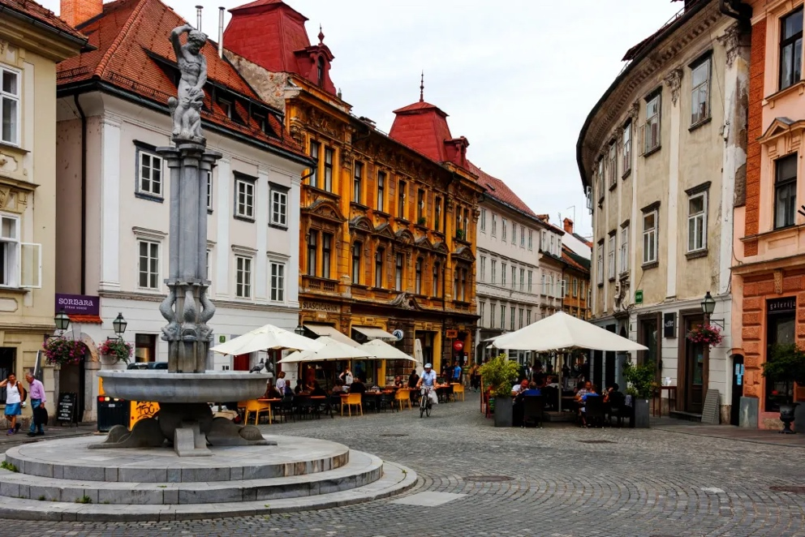
Depart US July 14, 2024
Day 1 (July 15): Arrival and City Tour of Ljubljana
Upon arrival in Ljubljana, you are met by your private driver for the transfer to the hotel for the check-in or luggage drop.
Shortly thereafter you will meet your guide for sightseeing including all of the major attractions.
You explore the old town with its mix of Baroque, Art Nouveau and Renaissance architectural styles. Visit the medieval Ljubljana castle which is the main symbol of the city. As a highlight, you enjoy scenic views over the city during a funicular ride.
After the tour you have evening free.
Day 2 (July 16): Full Day Trip to Postojna Caves and Predjama Castle
Today after breakfast you meet your driver-guide who takes you on a day trip to the world-famous Postojna Cave Park including Predjama Castle.
Your first stop today is the cave park, offering a wonderful subterranean world abundant with unusual sculptures and animals. Together with a local guide, you enjoy the cave's wonderful underground world of passages, halls, and galleries abundant with cave formations.
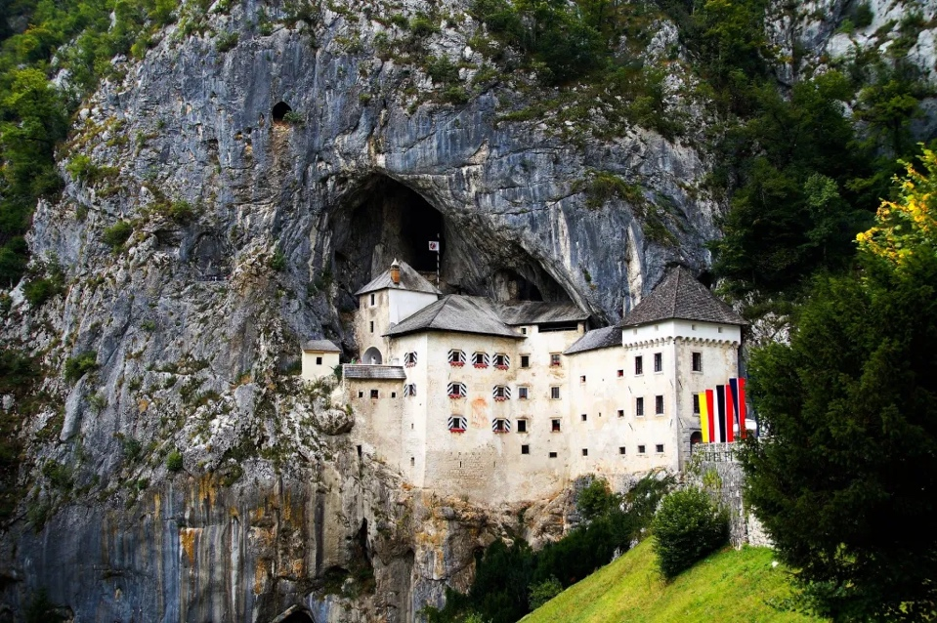
Not far from the cave, above the surface, you have a chance to admire the Predjama Castle embraced by the rock. Your guide in the castle tells you about times of knights, troubadours, weapons and of course the most fascinating legends.
*Note: guided tours on sites are led in small groups by the museum's guide.
After the tour we return to Ljubljana.
Group Dinner

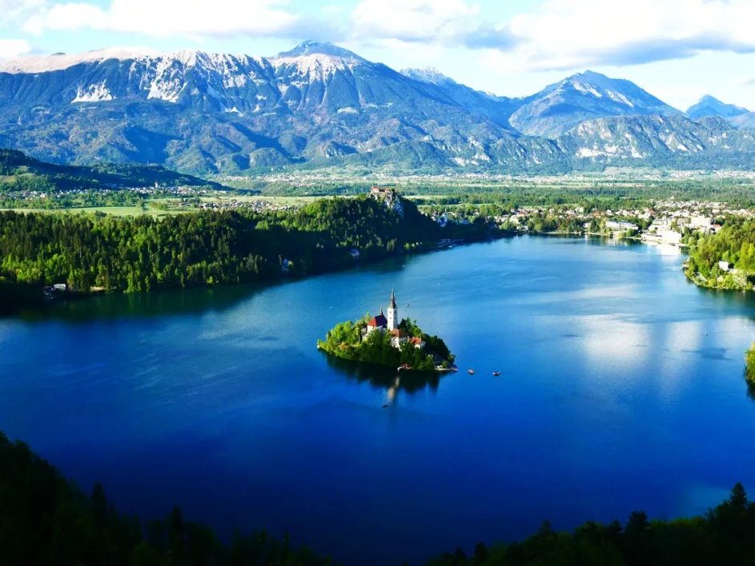
Day 3 (July 17): Full Day Tour to Lake Bled and Savica Waterfalls
Together with a guide and driver you leave Ljubljana for an exciting trip to the lake Bled.
Today you explore emerald green water and view over the mountains at this fairy-tale like lake. Sail with a traditional boat to the Bled Island in the middle of the lake and wander take your time to explore it.
Continue towards one of the greatest waterfalls in Slovenia - Savica, which is considered the most beautiful waterfall in Slovenia.
After the tour we return to Ljubljana. Dinner on own.

Day 4 (July 18): Departure
Following breakfast in your hotel, you check out and meet your private driver for a transfer for your departure to the airport. Destination home OR Dubrovnik for the Croatia & Montenegro Cruise. Airfare to Dubrovnik included if you are joining the Croatia & Montenegro Cruise with World Exposures.
Full day
Full Day Private Tour to Lake Bled and
Useful information:
- Accommodation at remarkable downtown hotels;
- Breakfasts at the hotels;
- Airport transfers and all transportation according to the itinerary;
- Breathtaking sightseeing tours according to the itinerary with professional English-speaking guides;
- Support line during the trip.
Not included: international flights, multiple arrival/departure transfers, other meals not mentioned in the program, optional tours and services, local city taxes and all personal expenses.
Please note:
1. Hotels availability is subject to change. In case current hotels are booked out we will provide alternative hotels of an equal value for you.
2. We include 1 vehicle for your arrival and departure transfers. If multiple vehicles are required additional transfer costs will apply.
3. Сity taxes are not included in the price. This is a small tax (1-5 EUR per person per night) collected by many cities. You will need to pay it at the hotel on checkout.
4. As a standard, our travel packages include one checked-in bag, one carry-on, and one handbag per person. Please let us know if you require additional luggage beyond our standard allowance. Please note that there may be an additional charge for extra luggage. The charge will depend on the amount and size of the luggage you wish to bring.

Pricing: Pre-Tour to Slovenia - Per person double = $1,909

